

A Mini Project Report

on

***Vehicle Service Provider WebApp***

Submitted To:

{Ms. }

DEPARTMENT OF COMPUTER SCIENCE AND ENGINEERING

## **NOIDA INSTITUE OF ENGINEERING AND TECHNOLOGY**,

## **GREATER NOIDA**

Submitted By:

1. VIKASH RAI (1813313126)
2. Abc
3. Cde

Introduction

“Vehicle Service Provider WebApp” is a project which aims in developing a Online Web Application to maintain all the daily work of Vehicle Service Centre . It also has a facility of admin login through which the admin can monitor the whole system. This System can be used to search for Assign Work, Add/Remove Mechanics(Servicers). The Admin after logging into his account can generate Service/Work Report.

Overall this project of ours is being developed to help the Service Centres to maintain the Services

**Acknowledgment**

It is a genuine pleasure to express my profound gratitude and deep regards to my mentor Professor Ms Pragya for his exemplary guidance, monitoring and constant encouragement. We would like to express our special thanks to Dr. C.S. Yadav Head Of Department of Computer Science and Engineering, NIET, Greater Noida who gave me the golden opportunity to do this wonderful project on the topic "Vehicle Service Provider" through the Implore websites, which helped me in doing a lot of Research and I came to know about so many new things.

**Table of Contents**

**Introduction** ………………………………………………………………………………………………… 1

* 1. Overview …………………………………………………………………… 1
  2. Objectives …………………………………………………………………… 2

**System Analysis** ……………………………………………………………………………………………… 3

2.1 Data Flow Diagrams (DFD) ……………………………………………. 10

2.1.1 DFD 0 Level ……………………………………………………… 10

2.2 Entity Relationship Diagram (ER-Diagram) …………………… 13

2.3 Flow Chart …………………………………………………………………… 14

**Tool/Environment**  ………………………………………………………………………………………... 36

3.1 Hardware Requirements ……………………………………………… 36

3.2 Software Requirements ………………………………………………. 36

**Software Description**  ……………………………………………………………………………………. 37

4.1 Visual Studio Code ………………………………………………………….. 37

4.2 Languages ……………………………………………………………………. 37

HTML, CSS and JavaScript…………………………………… 37

Why Using PHP …………………………………………………… 38

4.3 Why Using MySQL …………………………………………………………… 39

**Program Code** ……………………………………………………………………………………………… 41

**Implementation**  …………………………………………………………………………………………

**Limitations** ………………………………………………………………………………………………… 115

**Future Scope** ………………………………………………………………………………………………. 116

**Conclusion** …………………………………………………………………………………………………… 117

**Bibliography** ………………………………………………………………………………………………… A

* 1. **Overview**

Through computers organization, IT Firms, Universites and Businesses etc.. can transact to their clients in a convenient way using advance technologies and specially the Web Application, The Web Application is created for Service Centre functions through this "Implore" Admin (Manager) can lessen their errors and efforts in every Customer Support processing and transactions and in making reports.

It is Web Application which is developed in HTML, CSS, PHP & MySQL. The purpose of this Web Application is to manage the activities of service centre. Even a person can handle very easily; it means Web Interface is user friendly.

* 1. **Objective**
* **Practicality:** The software must be stable and can be operated by people with average intelligence.
* **Efficiency:** This involves accuracy, timeliness and comprehensiveness of the output.
* **Cost:** It is desirable to aim for a system with a minimum cost subject to the condition that it must satisfy all the requirements.
* **Portability:** The Web Application should be portable to all environments.

**Security:** This important aspect of design covers areas of physical security of data. This could be provided by a login facility enabling username and password for the user and administrator. Thus it makes the Admin work simple with 100% efficiently.

**2.1 Data Flow Diagram (DFD)**

Data flow diagram is graphical representation of flow of data in an information system. It uses defined symbols like rectangles, circles and arrows, plus short text labels, to show data inputs, outputs, storage points and the routes between each destination. Data flowcharts can range from simple, even hand-drawn process overviews, to in-depth, multi-level DFDs that dig progressively deeper into how the data is handled.

**2.1.1 DFD 0 Level**

The 0 Level DFD shows flow of data of application. DFD Level 0 is also called a Context Diagram. It’s a basic overview of the whole system or process being analyzed or modeled.

Requester

Admin

Report

Approval

Submit request

Check status

**2.2 Entity Relationship Diagram (ER-Diagram)**

An Entity Relationship Diagram (ERD) is a visual representation of different entities within a system and how they relate to each other. Entity relationship diagrams are used in software engineering during the planning stages of the software project. They help to identify different system elements and their relationships with each other.

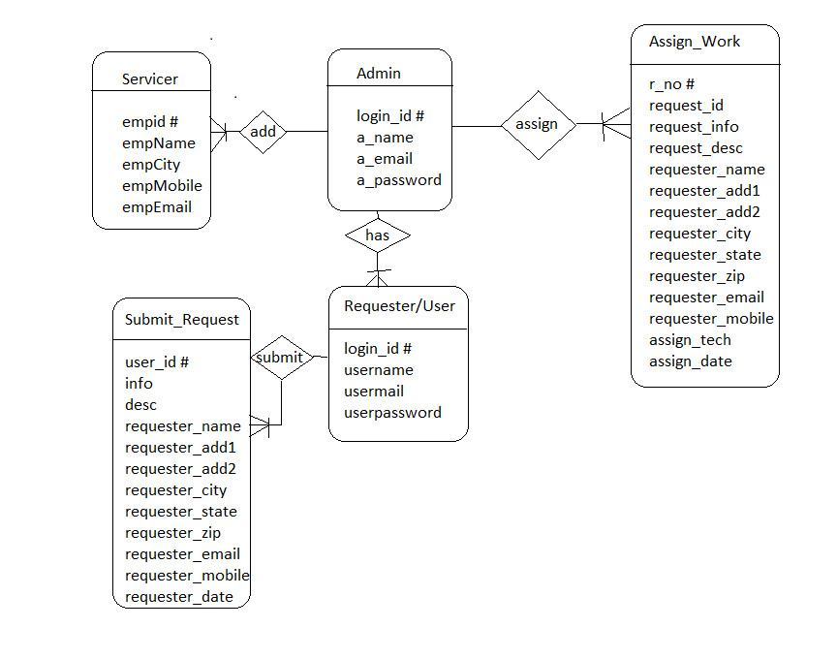

**2.3 Flow Chart**

A flowchart is a diagram that depicts a process, system or computer algorithm. They are widely used in multiple fields to document, study, plan, improve and communicate often complex processes in clear, easy-to-understand diagrams. Flowcharts, sometimes spelled as flow charts, use rectangles, ovals, diamonds and potentially numerous other shapes to define the type of step, along with connecting arrows to define flow and sequence.

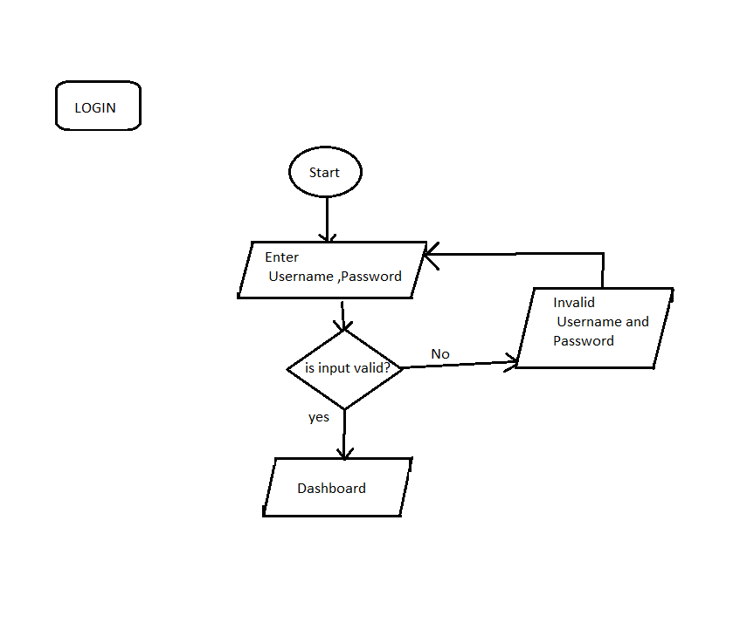

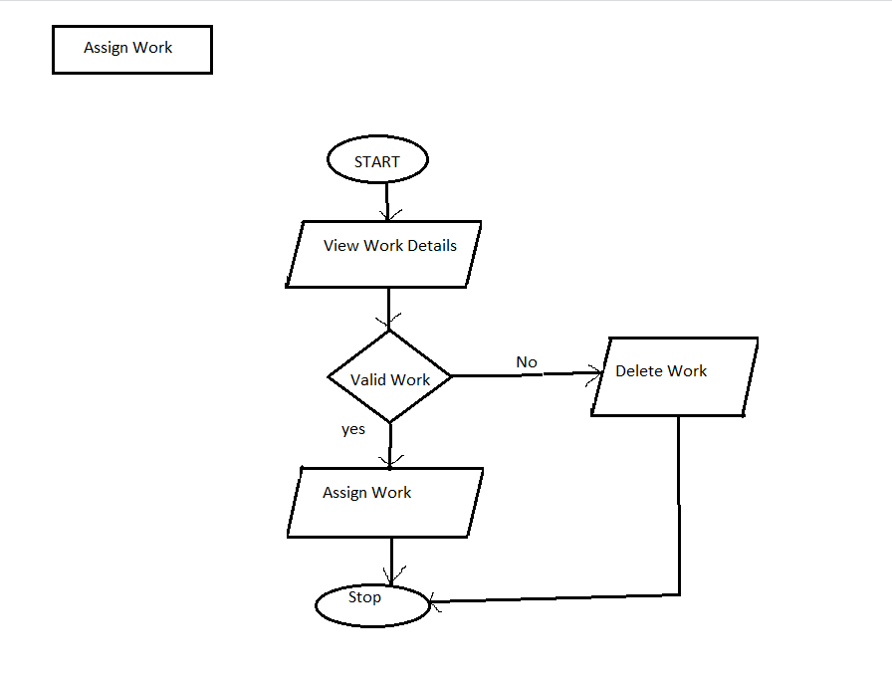

Tools and Environment

**3.1 Hardware Requirements**

|  |  |
| --- | --- |
| Processor | 1.6 GHz or Faster Processor |
| RAM | 1.5 GB |
| Disk Space | 4GB of Available Hard Disk |
| Graphic | DirectX 9-Capable Video Card |
| Display | 1024 X 768 or Higher Resolution |

**3.2 Software Requirements**

|  |  |
| --- | --- |
| Operating System | Windows 10 |
| Front End | HTML, CSS, JS |
| Frameworks/Library | Bootstrap, FontAwesome, Google Font |
| Back End | PHP |
| Text Editor | Visual Studio Code |
| Database | MySQL |
| Web Browser | Google Chrome |
| Web Server | Apache |

1. Software Description

**4.1 Visual Studio Code**

Visual Studio Code was announced on April 29, 2015 by Microsoft at the 2015 Build conference. A Preview build was released shortly thereafter.

On November 18, 2015, Visual Studio Code was released under the MIT License and its source code posted to GitHub. Extension support was also announced.

On April 14, 2016, Visual Studio Code graduated the public preview stage and was released to web.Visual Studio Code is a source code editor developed by Microsoft for Windows, Linux and macOS. It includes support for debugging, embedded Git control, syntax highlighting, intelligent code completion, snippets, and code refactoring. It is also customizable, so users can change the editor's theme, keyboard shortcuts, and preferences. It is free and open-source, although the official download is under a proprietary license..

**4.2 Languages**

**HTML**

Hypertext Markup Language (HTML) is the standard markup language for creating web pages and web applications. With Cascading Style Sheets (CSS) and JavaScript, it forms a triad of cornerstone technologies for the World Wide Web.

Web browsers receive HTML documents from a web server or from local storage and render the documents into multimedia web pages. HTML describes the structure of a web page semantically and originally included cues for the appearance of the document.

**CSS**

Cascading Style Sheets (CSS) is a style sheet language used for describing the presentation of a document written in a markup language like HTML. CSS is a cornerstone technology of the World Wide Web, alongside HTML and JavaScript.

CSS is designed to enable the separation of presentation and content, including layout, colors, and fonts. This separation can improve content accessibility, provide more flexibility and control in the specification of presentation characteristics, enable multiple web pages to share formatting by specifying the relevant CSS in a separate .css file, and reduce complexity and repetition in the structural content.

**JavaScript**

JavaScript often abbreviated as JS, is a high-level, interpreted programming language. It is a language which is also characterized as dynamic, weakly typed, prototype-based and multi-paradigm.

**Why using PHP**

Every PHP is an open source language and all its components are free to use and distribute. PHP is server-side scripting language. It is embedded in HTML source code. It is used to generate dynamic pages content. People find it useful to develop websites and dynamic web pages. It is platform independent. PHP supports all major web servers such as Apache, Microsoft IIS and Netscape etc. All the major database such as Mysql, PostgreSQL, Oracle, Sybase, Microsoft SQL Server is supported by PHP. The main reasons for using PHP language are:

1. It collects form data and save data send by mail.
2. It sends and receives cookies by accessing cookies variables.
3. It provides add, delete and modify element function within our database.
4. Through PHP, we can restrict users to access some pages of our website.
5. It can encrypt data, so that our data will become more secure.

**4.3 Why using MySQL**

Mysql is the most popular open source relational database management system .It is one of the best RDBMS being used to develop web-based software applications. It is easy to use and fast RDBMS. There are many good reasons which help us to develop website using this RDBMS:

* It is open-source, so available for free.
* It works on many operating system and with many languages including PHP, PERL, C, C++ etc.
* Mysql is customizable.
* Mysql works very friendly to PHP.
* Mysql works very quickly and works well even with large data sets.

Program Codes along with WebApp Snapshots

Index.php

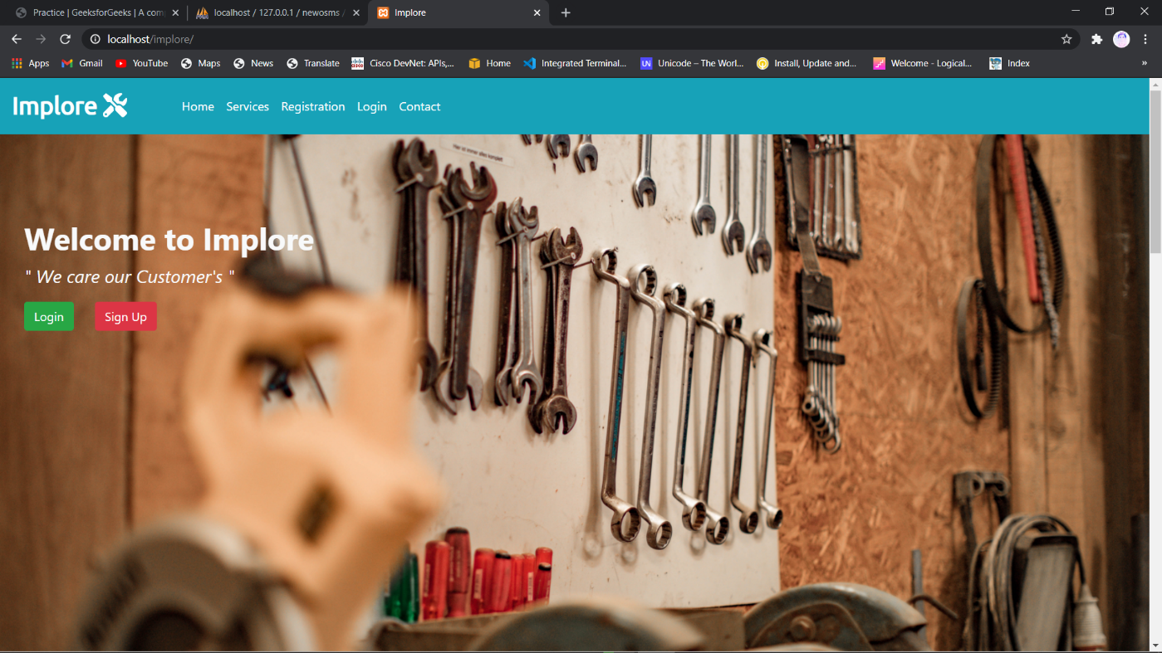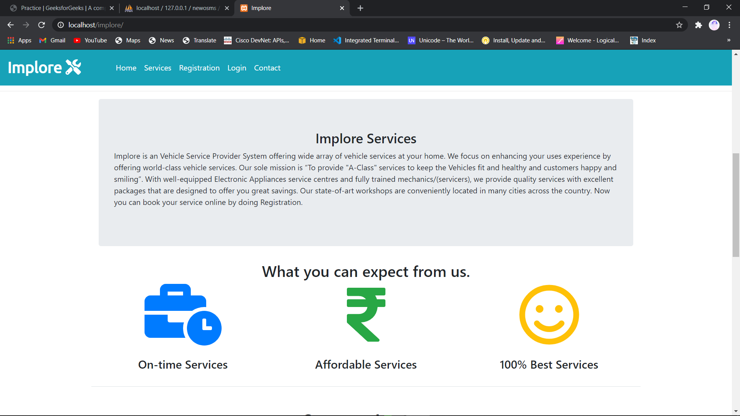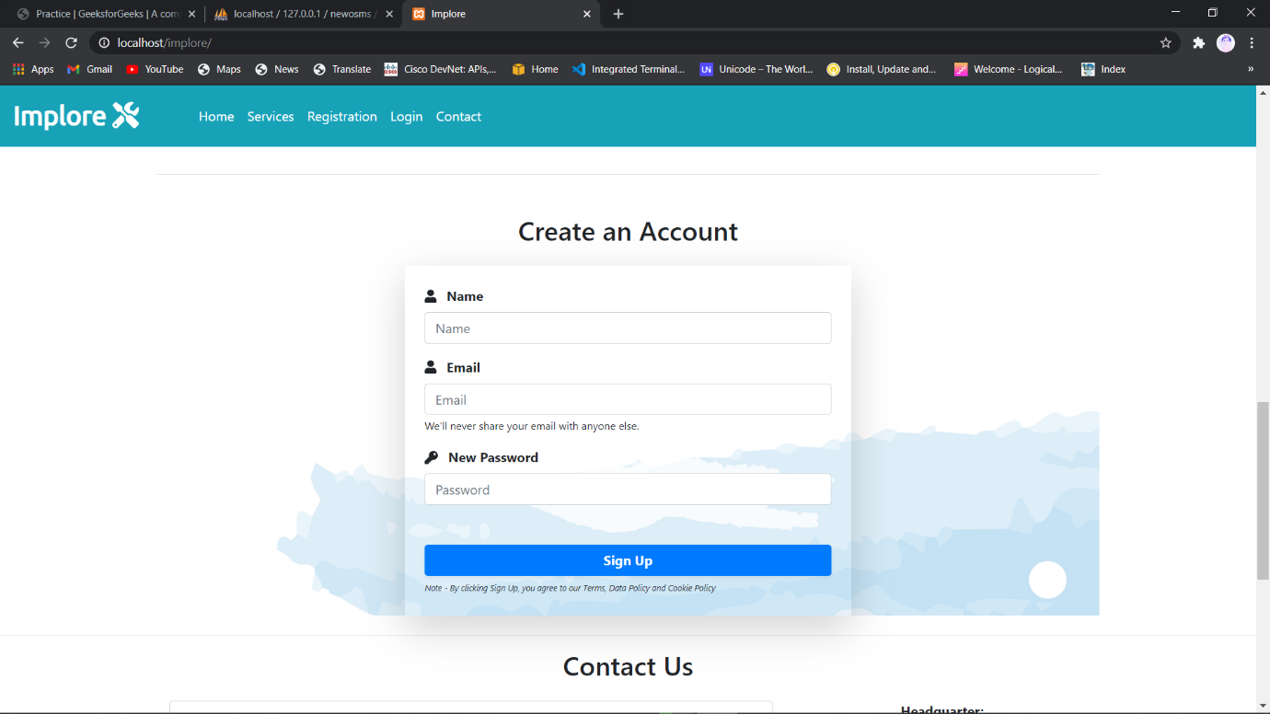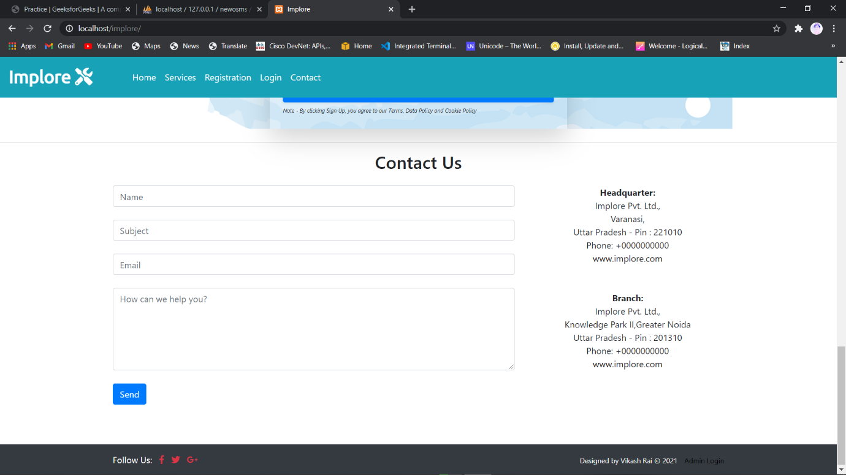

<!DOCTYPE *html*>

<html *lang*="en">

<head>

 <meta *charset*="UTF-8">

 <meta *name*="viewport" *content*="width=device-width, initial-scale=1.0">

 <meta *http-equiv*="X-UA-Compatible" *content*="ie=edge">

*<!-- Bootstrap CSS -->*

 <link *rel*="stylesheet" *href*="css/bootstrap.min.css">

*<!-- Font Awesome CSS -->*

 <link *rel*="stylesheet" *href*="css/all.min.css">

*<!-- Google Font -->*

 <link *href*="https://fonts.googleapis.com/css?family=Ubuntu&display=swap" *rel*="stylesheet">

*<!-- Custom CSS -->*

 <link *rel*="stylesheet" *href*="css/custom.css">

 <title>Implore</title>

</head>

<body>

*<!-- Start Navigation -->*

 <nav *class*="navbar navbar-expand-sm navbar-dark bg-info pl-3 fixed-top">

  <a *href*="index.php" *class*="navbar-brand">Implore <i *class*="fas fa-tools"></i></a>

  <button *type*="button" *class*="navbar-toggler" *data-toggle*="collapse" *data-target*="#myMenu">

   <span *class*="navbar-toggler-icon"></span>

  </button>

  <div *class*="collapse navbar-collapse" *id*="myMenu">

   <ul *class*="navbar-nav pl-5 custom-nav ">

    <li *class*="nav-item "><a *href*="index.php" *class*="nav-link">Home</a></li>

    <li *class*="nav-item"><a *href*="#Services" *class*="nav-link">Services</a></li>

    <li *class*="nav-item"><a *href*="#registration" *class*="nav-link">Registration</a></li>

    <li *class*="nav-item"><a *href*="Requester/RequesterLogin.php" *class*="nav-link">Login</a></li>

    <li *class*="nav-item"><a *href*="#Contact" *class*="nav-link">Contact</a></li>

   </ul>

  </div>

 </nav> *<!-- End Navigation -->*

*<!-- Start Header Jumbotron-->*

 <header *class*="jumbotron back-image" *style*="background-image:url(images/second.jpg);">

  <div *class*="myclass mainHeading">

   <h1 *class*="

   text-light font-weight-bold">Welcome to Implore</h1>

   <p *class*="font-italic text-light">" We care our Customer's "</p>

   <a *href*="Requester/RequesterLogin.php" *class*="btn btn-success mr-4">Login</a>

   <a *href*="#registration" *class*="btn btn-danger mr-4">Sign Up</a>

  </div>

 </header> *<!-- End Header Jumbotron-->*

<hr></hr>

*<!-- Start Introduction Section -->*

 <div *class*="container">

  <div *class*="jumbotron">

   <h3 *class*="text-center">Implore Services</h3>

   <p>

   Implore is an Vehicle Service Provider System offering wide array of vehicle services at your home. We focus on enhancing your uses experience by offering world-class vehicle services. Our sole mission is “To provide "A-Class" services to keep the Vehicles fit and healthy and customers happy and smiling”.

    With well-equipped Electronic Appliances service centres and fully trained mechanics/(servicers), we provide quality services with excellent packages that are designed to offer you great savings.

    Our state-of-art workshops are conveniently located in many

    cities across the country. Now you can book your service online by doing Registration.

   </p>

  </div>

 </div> *<!-- End Introduction Section Container -->*

*<!-- Start Services Section -->*

 <div *class*="container text-center border-bottom mt-50" *id*="Services">

  <h2>What you can expect from us.</h2>

  <div *class*="row mt-40">

   <div *class*="col-sm-4 mb-4">

    <a *href*="#"><i *class*="fas fa-business-time fa-8x text-primary"></i></a>

    <h4 *class*="mt-4">On-time Services</h4>

   </div>

   <div *class*="col-sm-4 mb-4">

    <a *href*="#"><i *class*="fas fa-rupee-sign fa-8x text-success"></i></i></a>

    <h4 *class*="mt-4">Affordable Services</h4>

   </div>

   <div *class*="col-sm-4 mb-4">

    <a *href*="#"><i *class*="< far fa-smile fa-8x text-warning"></i></a>

    <h4 *class*="mt-4">100% Best Services</h4>

   </div>

  </div>

 </div> *<!-- End Services Section Container -->*

*<!-- Start Registration Form -->*

 <?php **include**('UserRegistration.php') ?>

*<!-- End Registration Form Container -->*

*<!-- Start Happy Customer -->*

 </div> *<!-- End Happy Customer -->*

 <hr></hr>

*<!-- Start Contact US -->*

 <div *class*="container" *id*="Contact">

  <h2 *class*="text-center mb-4">Contact Us</h2>

  <div *class*="row">

*<!-- Start 1st Column -->*

    <?php **include**('contactform.php') ?>

*<!-- End 1st Column -->*

   <div *class*="col-md-4 text-center"> *<!-- Start 2nd Column -->*

    <strong>Headquarter:</strong><br>

    Implore Pvt. Ltd.,<br>

    Varanasi,<br>

    Uttar Pradesh - Pin : 221010<br>

    Phone: +0000000000<br>

    <a *href*="#index.php" *target*="_blank">www.implore.com</a><br>

    <br> <br>

    <strong>Branch:</strong><br>

    Implore Pvt. Ltd.,<br>

    Knowledge Park II,Greater Noida<br>

    Uttar Pradesh - Pin : 201310<br>

    Phone: +0000000000<br>

    <a *href*="#index.php" *target*="_blank">www.implore.com</a><br>

   </div> *<!-- End 2nd Column -->*

  </div>

 </div> *<!-- End Contact US -->*

*<!-- Start Footer -->*

 <footer *class*="container-fluid bg-dark mt-5 text-white">

  <div *class*="container">

   <div *class*="row py-3">

    <div *class*="col-md-6"> *<!-- Start 1st Column -->*

     <span *class*="pr-2">Follow Us: </span>

     <a *href*="#" *target*="_blank" *class*="pr-2 fi-color"><i *class*="fab fa-facebook-f"></i></a>

     <a *href*="#" *target*="_blank" *class*="pr-2 fi-color"><i *class*="fab fa-twitter"></i></a>

     <a *href*="#" *target*="_blank" *class*="pr-2 fi-color"><i *class*="fab fa-google-plus-g"></i></a>

    </div>

*<!-- End 1st Column -->*

    <div *class*="col-md-6 text-right"> *<!-- Start 2nd Column -->*

     <small>Designed by Vikash Rai &copy; 2021</small>

     <small *class*="ml-2"><a *href*="Admin/login.php">Admin Login</a></small>

    </div> *<!-- End 2nd Column -->*

   </div>

  </div>

 </footer>

*<!-- JavaScript -->*

 <script *src*="js/jquery.min.js"></script>

 <script *src*="js/popper.min.js"></script>

 <script *src*="js/bootstrap.min.js"></script>

 <script *src*="js/all.min.js"></script>

</body>

</html>

**contactform.php**

<?php

*// The contact Us Form wont work with Local Host but it will work on Live Server*

if(**isset**($_REQUEST['submit'])) {

*// Checking for Empty Fields*

 if(($_REQUEST['name'] == "") || ($_REQUEST['subject'] == "") || ($_REQUEST['email'] == "") || ($_REQUEST['message'] == "")){

*// msg displayed if required field missing*

  $msg = '<div class="alert alert-warning col-sm-6 ml-5 mt-2" role="alert"> Fill All Fileds </div>';

 } else {

 $name = $_REQUEST['name'];

 $subject = $_REQUEST['subject'];

 $email = $_REQUEST['email'];

 $message = $_REQUEST['message'];

 $mailTo = "vikashrai2507@gmail.com";

 $headers = "From: ". $email;

 $txt = "You have received an email from ". $name. ".\n\n".$message;

**mail**($mailTo, $subject, $txt, $headers);

 $msg = '<div class="alert alert-success col-sm-6 ml-5 mt-2" role="alert"> Sent Successfully </div>';

}

}

?>

<div *class*="col-md-8 " > *<!-- Start 1st Column -->*

  <form *action*="" *method*="POST">

   <input *type*="text" *class*="form-control" *name*="name" *placeholder*="Name"><br>

   <input *type*="text" *class*="form-control" *name*="subject" *placeholder*="Subject"><br>

   <input *type*="email" *class*="form-control" *name*="email" *placeholder*="Email"><br>

   <textarea *class*="form-control" *name*="message" *placeholder*="How can we help you?" *style*="height:150px;"></textarea><br>

   <input *type*="submit" *class*="btn btn-primary" *value*="Send" *name*="submit"><br><br>

  </form>

</div> *<!-- End 1st Column -->*

UserRegistration.php

<?php

**include**('dbConnection.php');

if(**isset**($_REQUEST['rSignup'])){

*// Checking for Empty Fields*

  if(($_REQUEST['rName'] == "") || ($_REQUEST["rEmail"] == "") || ($_REQUEST['rPassword'] == "")){

    $regmsg = '<div class="alert alert-warning mt-2" role="alert">All Fields are Required</div>';

  } else {

*// Email Already Registered*

    $sql = "SELECT r_email FROM requesterlogin_tb WHERE r_email ='".$_REQUEST['rEmail']."'";

    $result = $conn->**query**($sql);

    if($result->num_rows==1){

      $regmsg = '<div class="alert alert-warning mt-2" role="alert">Email ID Already Registered</div>';

    } else {

*// Assigning User's Values to Variables*

        $rName = $_REQUEST['rName'];

        $rEmail = $_REQUEST['rEmail'];

        $rPassword = $_REQUEST['rPassword'];

        $sql = "INSERT INTO requesterlogin_tb(r_name, r_email, r_password) VALUES('$rName', '$rEmail', '$rPassword')";

        if($conn->**query**($sql) == TRUE){

          $regmsg = '<div class="alert alert-success mt-2" role="alert">Account Succefully Created</div>';

        } else {

          $regmsg = '<div class="alert alert-danger mt-2" role="alert">Unable to Create Account</div>';

        }

      }

  }

}

?>

<div *class*="container pt-5 " *id*="registration" >

  <h2 *class*="text-center"  >Create an Account</h2>

  <div *class*="row mt-4 mb-4  " *style*="background-image:url(images/bg.png);" >

   <div *class*="col-md-6 offset-md-3 " >

    <form *action*="" *class*="shadow-lg p-4" *method*="POST">

     <div *class*="form-group ">

      <i *class*="fas fa-user"></i> <label *for*="name" *class*="font-weight-bold pl-2">Name</label><input *type*="text" *class*="form-control" *placeholder*="Name" *name*="rName">

     </div>

     <div *class*="form-group">

      <i *class*="fas fa-user"></i> <label *for*="email" *class*="font-weight-bold pl-2">Email</label><input *type*="email" *class*="form-control" *placeholder*="Email" *name*="rEmail">

      <small *class*="form-text">We'll never share your email with anyone else.</small>

     </div>

     <div *class*="form-group">

      <i *class*="fas fa-key"></i> <label *for*="pass" *class*="font-weight-bold pl-2">New Password</label><input *type*="password" *class*="form-control" *placeholder*="Password" *name*="rPassword">

     </div>

     <button *type*="submit" *class*="btn btn-primary mt-5 btn-block shadow-sm font-weight-bold" *name*="rSignup">Sign Up</button>

     <em *style*="font-size:10px;">Note - By clicking Sign Up, you agree to our Terms, Data Policy and Cookie Policy</em>

     <?php if(**isset**($regmsg)) {**echo** $regmsg;} ?>

    </form>

   </div>

  </div>

 </div>

dbConnection.php

<?php

$db_host = "localhost";

$db_user = "root";

$db_password = "";

$db_name = "newosms";

$db_port = 3306;

*// Create Connection*

$conn = new **mysqli**($db_host, $db_user, $db_password, $db_name, $db_port);

*// Checking Connection*

if($conn->connect_error){

 die("Connection Failed");

}

*// else {*

*//  echo "Connect";*

*// }*

?>

Logout.php

<?php

**session_start**();

**session_destroy**();

**echo** "<script> location.href='index.php';</script>"

?>

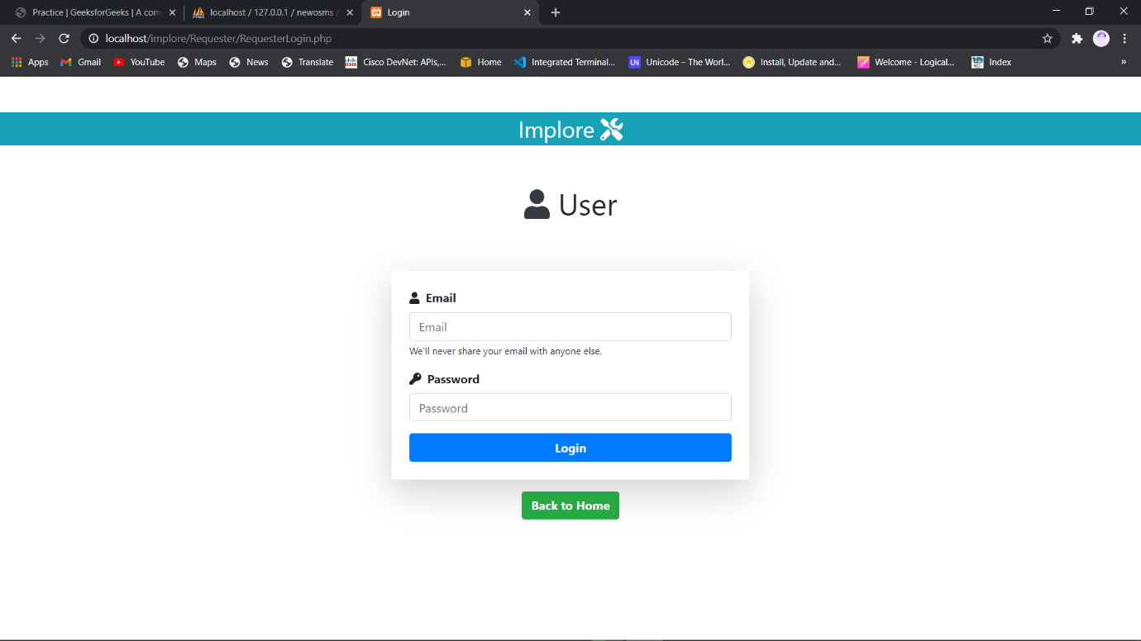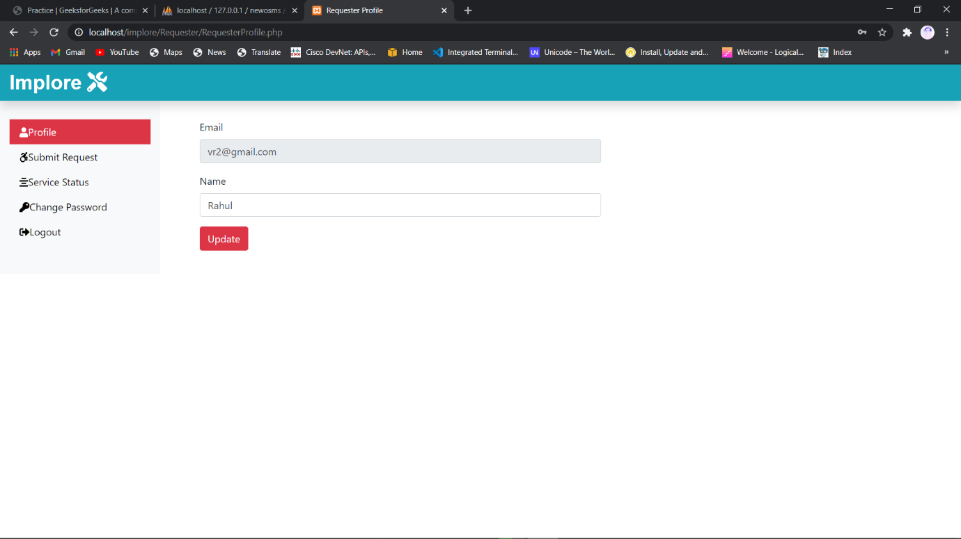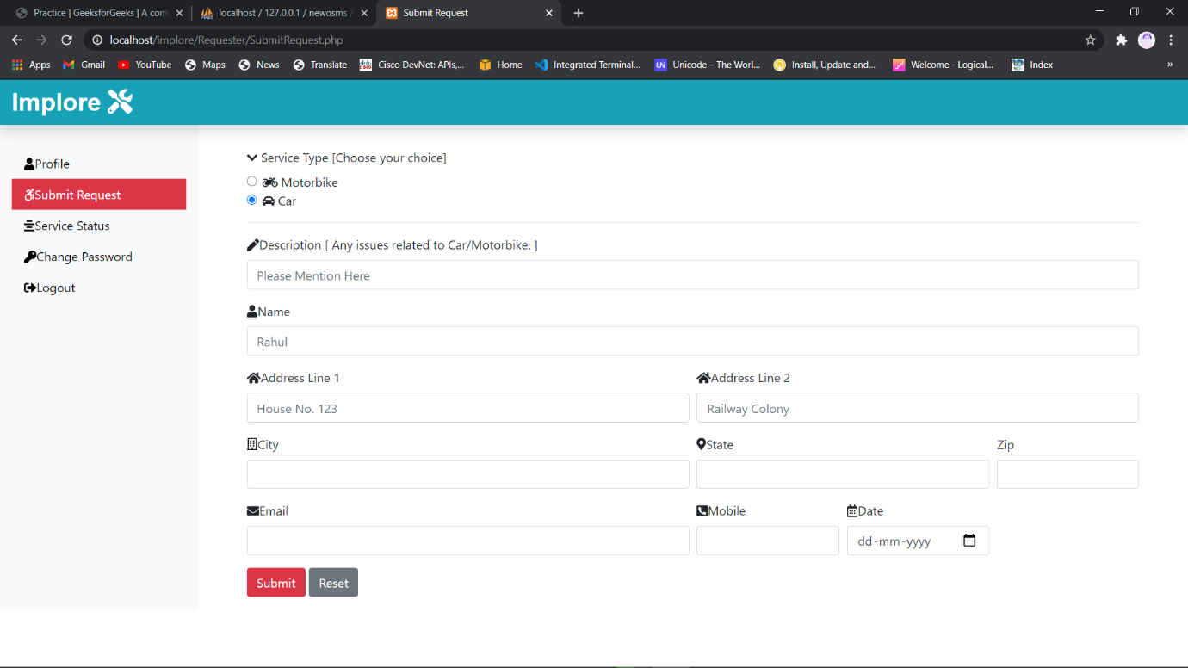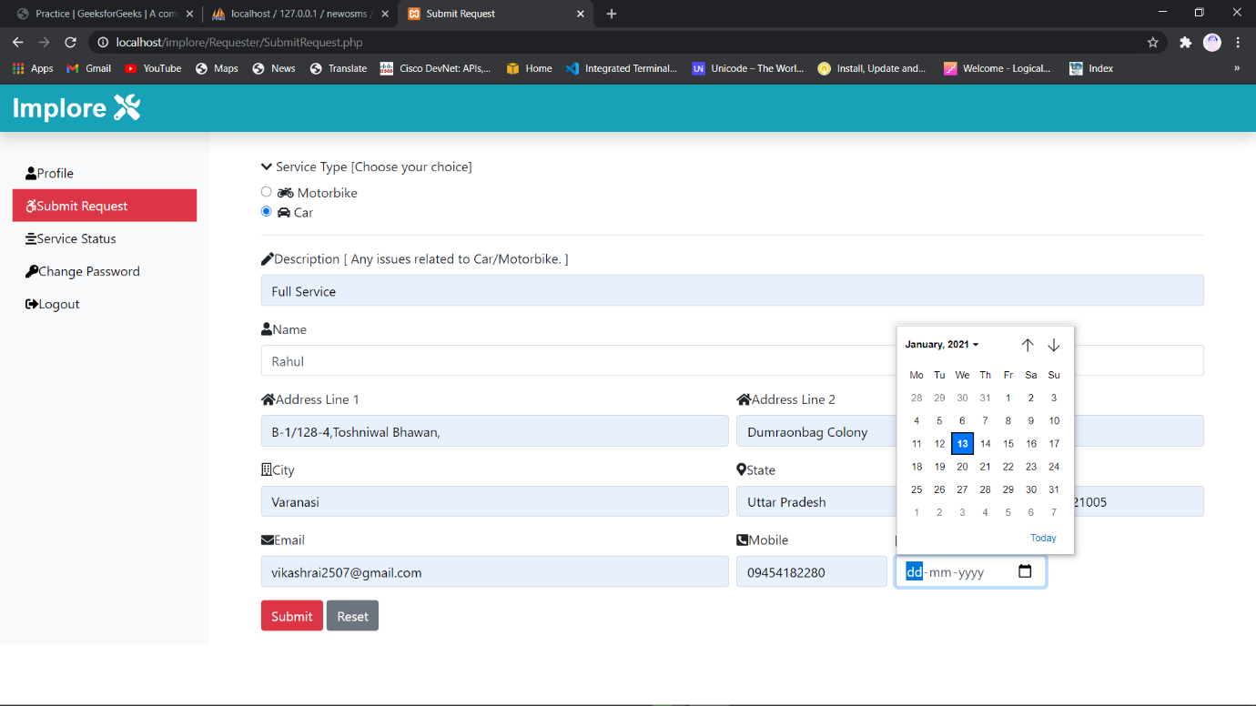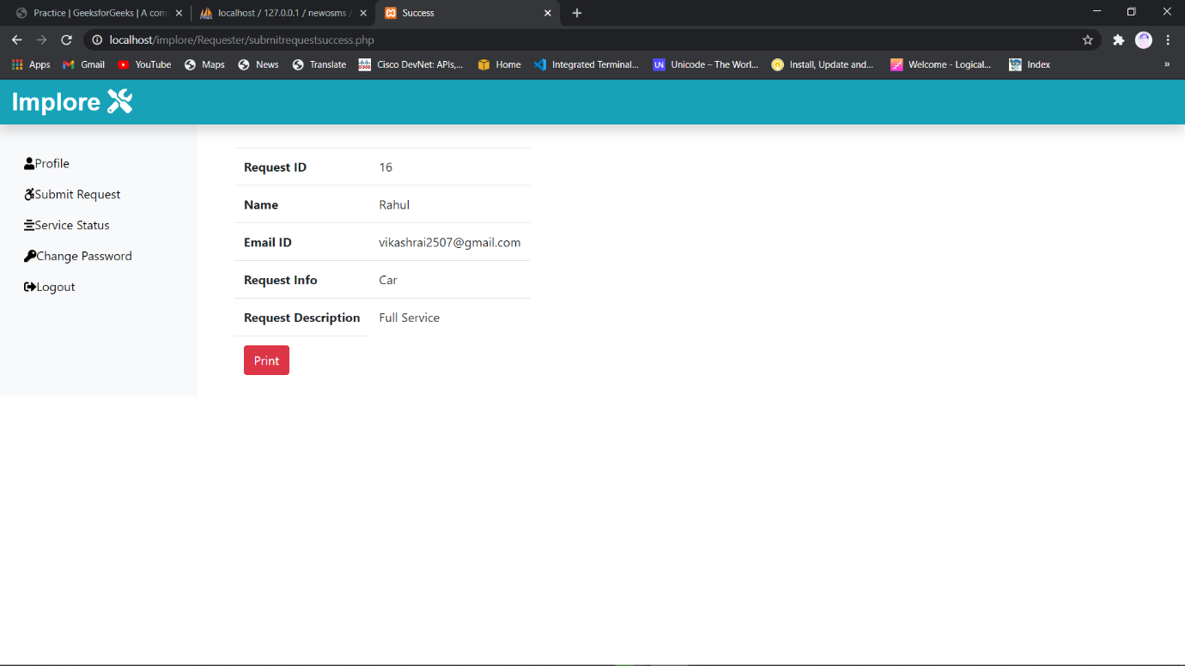Re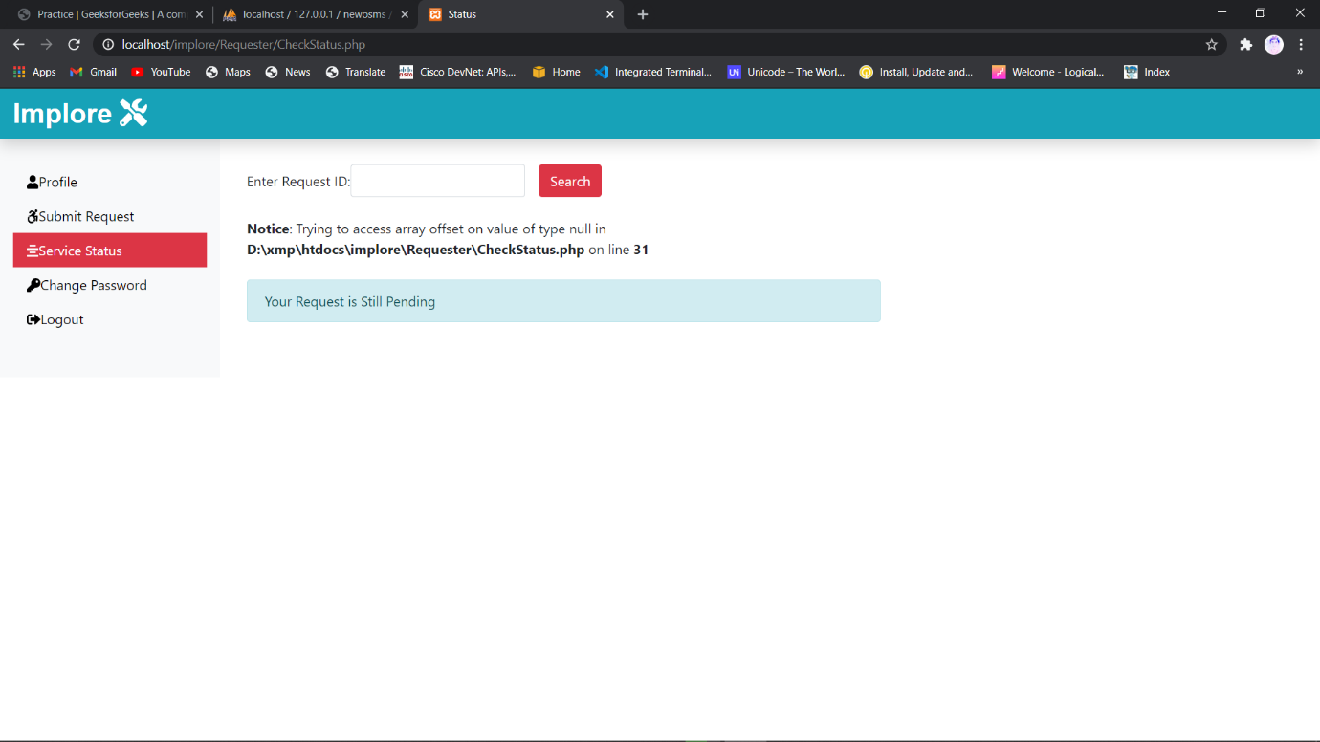

Requesterlogin.php

<?php

**include**('../dbConnection.php');

**session_start**();

 if(!**isset**($_SESSION['is_login'])){

  if(**isset**($_REQUEST['rEmail'])){

   $rEmail = **mysqli_real_escape_string**($conn, **trim**($_REQUEST['rEmail']));

   $rPassword = **mysqli_real_escape_string**($conn, **trim**($_REQUEST['rPassword']));

   $sql = "SELECT r_email, r_password FROM requesterlogin_tb WHERE r_email = '".$rEmail."' AND r_password = '".$rPassword."' limit 1";

   $result = $conn->**query**($sql);

   if($result->num_rows == 1){

    $_SESSION['is_login'] = true;

    $_SESSION['rEmail'] = $rEmail;

**echo** "<script> location.href='RequesterProfile.php';</script>";

    exit;

   } else {

    $msg = '<div class="alert alert-warning mt-2">Enter Valid Email and Password</div>';

   }

  }

 } else {

**echo** "<script> location.href='RequesterProfile.php';</script>";

 }

?>

<!DOCTYPE *html*>

<html *lang*="en">

<head>

 <meta *charset*="UTF-8">

 <meta *name*="viewport" *content*="width=device-width, initial-scale=1.0">

 <meta *http-equiv*="X-UA-Compatible" *content*="ie=edge">

*<!-- Bootstrap CSS -->*

 <link *rel*="stylesheet" *href*="../css/bootstrap.min.css">

*<!-- Font Awesome CSS -->*

 <link *rel*="stylesheet" *href*="../css/all.min.css">

 <style>

  .custom-margin {

   margin-top: 8vh;

  }

 </style>

 <title>Login</title>

</head>

<body>

 <div *class*="mb-3 mt-5 text-center bg-info text-light" *style*="font-size: 30px;" >

  <span>Implore </span>

  <i *class*="fas fa-tools"></i>

 </div>

 <p *class*="text-center mt-5 " *style*="font-size:40px;"><i *class*="fas fa-user text-dark"></i><span> User </span></p>

 <div *class*="container-fluid ">

  <div *class*="row justify-content-center custom-margin ">

   <div *class*="col-sm-6 col-md-4 ">

    <form *action*="" *class*="shadow-lg p-4" *method*="POST">

     <div *class*="form-group">

      <i *class*="fas fa-user"></i><label *for*="email" *class*="font-weight-bold pl-2">Email</label><input *type*="email" *class*="form-control" *placeholder*="Email" *name*="rEmail">

      <small *class*="form-text">We'll never share your email with anyone else.</small>

     </div>

     <div *class*="form-group">

      <i *class*="fas fa-key"></i><label *for*="pass" *class*="font-weight-bold pl-2">Password</label><input *type*="password" *class*="form-control" *placeholder*="Password" *name*="rPassword">

     </div>

     <button *type*="submit" *class*="btn btn-outline-primary mt-3 font-weight-bold btn-block shadow-sm">Login</button>

     <?php if(**isset**($msg)) {**echo** $msg;} ?>

    </form>

    <div *class*="text-center"><a *href*="../index.php" *class*="btn btn-success mt-3 font-weight-bold shadow-sm">Back to Home</a></div>

   </div>

  </div>

 </div>

*<!-- JavaScript Files -->*

 <script *src*="../js/jquery.min.js"></script>

 <script *src*="../js/popper.min.js"></script>

 <script *src*="../js/bootstrap.min.js"></script>

 <script *src*="../js/all.min.js"></script>

</body>

</html>

Requesterprofile.php

<?php

**include**('../dbConnection.php');

**session_start**();

 if(!**isset**($_SESSION['is_login'])){

  if(**isset**($_REQUEST['rEmail'])){

   $rEmail = **mysqli_real_escape_string**($conn, **trim**($_REQUEST['rEmail']));

   $rPassword = **mysqli_real_escape_string**($conn, **trim**($_REQUEST['rPassword']));

   $sql = "SELECT r_email, r_password FROM requesterlogin_tb WHERE r_email = '".$rEmail."' AND r_password = '".$rPassword."' limit 1";

   $result = $conn->**query**($sql);

   if($result->num_rows == 1){

    $_SESSION['is_login'] = true;

    $_SESSION['rEmail'] = $rEmail;

**echo** "<script> location.href='RequesterProfile.php';</script>";

    exit;

   } else {

    $msg = '<div class="alert alert-warning mt-2">Enter Valid Email and Password</div>';

   }

  }

 } else {

**echo** "<script> location.href='RequesterProfile.php';</script>";

 }

?>

<!DOCTYPE *html*>

<html *lang*="en">

<head>

 <meta *charset*="UTF-8">

 <meta *name*="viewport" *content*="width=device-width, initial-scale=1.0">

 <meta *http-equiv*="X-UA-Compatible" *content*="ie=edge">

*<!-- Bootstrap CSS -->*

 <link *rel*="stylesheet" *href*="../css/bootstrap.min.css">

*<!-- Font Awesome CSS -->*

 <link *rel*="stylesheet" *href*="../css/all.min.css">

 <style>

  .custom-margin {

   margin-top: 8vh;

  }

 </style>

 <title>Login</title>

</head>

<body>

 <div *class*="mb-3 mt-5 text-center bg-info text-light" *style*="font-size: 30px;" >

  <span>Implore </span>

  <i *class*="fas fa-tools"></i>

 </div>

 <p *class*="text-center mt-5 " *style*="font-size:40px;"><i *class*="fas fa-user text-dark"></i><span> User </span></p>

 <div *class*="container-fluid ">

  <div *class*="row justify-content-center custom-margin ">

   <div *class*="col-sm-6 col-md-4 ">

    <form *action*="" *class*="shadow-lg p-4" *method*="POST">

     <div *class*="form-group">

      <i *class*="fas fa-user"></i><label *for*="email" *class*="font-weight-bold pl-2">Email</label><input *type*="email" *class*="form-control" *placeholder*="Email" *name*="rEmail">

      <small *class*="form-text">We'll never share your email with anyone else.</small>

     </div>

     <div *class*="form-group">

      <i *class*="fas fa-key"></i><label *for*="pass" *class*="font-weight-bold pl-2">Password</label><input *type*="password" *class*="form-control" *placeholder*="Password" *name*="rPassword">

     </div>

     <button *type*="submit" *class*="btn btn-outline-primary mt-3 font-weight-bold btn-block shadow-sm">Login</button>

     <?php if(**isset**($msg)) {**echo** $msg;} ?>

    </form>

    <div *class*="text-center"><a *href*="../index.php" *class*="btn btn-success mt-3 font-weight-bold shadow-sm">Back to Home</a></div>

   </div>

  </div>

 </div>

*<!-- JavaScript Files -->*

 <script *src*="../js/jquery.min.js"></script>

 <script *src*="../js/popper.min.js"></script>

 <script *src*="../js/bootstrap.min.js"></script>

 <script *src*="../js/all.min.js"></script>

</body>

</html>

SubmitRequest.php

<?php

**define**('TITLE', 'Submit Request');

**define**('PAGE', 'SubmitRequest');

**include**('includes/header.php');

**include**('../dbConnection.php');

**session_start**();

if($_SESSION['is_login']){

 $rEmail = $_SESSION['rEmail'];

} else {

**echo** "<script> location.href='RequesterLogin.php'</script>";

}

if(**isset**($_REQUEST['submitrequest'])){

*// Checking for empty fields*

 if(($_REQUEST['requestinfo'] == "") || ($_REQUEST['requestdesc'] == "") || ($_REQUEST['requestername'] == "") || ($_REQUEST['requesteradd1'] == "") || ($_REQUEST['requesteradd2'] == "") || ($_REQUEST['requestercity'] == "") || ($_REQUEST['requesterstate'] == "") || ($_REQUEST['requesterzip'] == "") || ($_REQUEST['requesteremail'] == "") || ($_REQUEST['requestermobile'] == "") || ($_REQUEST['requestdate'] == "")){

  $msg = "<div class='alert alert-warning col-sm-6 ml-5 mt-2'>Fill All Fields</div>";

 } else {

  $rinfo = $_REQUEST['requestinfo'];

  $rdesc = $_REQUEST['requestdesc'];

  $rname = $_REQUEST['requestername'];

  $radd1 = $_REQUEST['requesteradd1'];

  $radd2 = $_REQUEST['requesteradd2'];

  $rcity = $_REQUEST['requestercity'];

  $rstate = $_REQUEST['requesterstate'];

  $rzip = $_REQUEST['requesterzip'];

  $remail = $_REQUEST['requesteremail'];

  $rmobile = $_REQUEST['requestermobile'];

  $rdate = $_REQUEST['requestdate'];

  $sql = "INSERT INTO submitrequest_tb(request_info, request_desc, requester_name, requester_add1, requester_add2, requester_city, requester_state, requester_zip, requester_email, requester_mobile, request_date)VALUES('$rinfo', '$rdesc', '$rname', '$radd1', '$radd2', '$rcity', '$rstate', '$rzip', '$remail', '$rmobile', '$rdate')";

  if($conn->**query**($sql) == TRUE){

    $genid = **mysqli_insert_id**($conn);

    $msg = "<div class='alert alert-success col-sm-6 ml-5 mt-2'>Request Submitted Sucessfully</div>";

    $_SESSION['myid'] = $genid;

**echo** "<script> location.href='submitrequestsuccess.php'</script>";

  } else {

    $msg = "<div class='alert alert-danger col-sm-6 ml-5 mt-2'>Unable to Submit Your Request</div>";

  }

 }

}

?>

<div *class*="col-sm-9 col-md-10 mt-5"> *<!-- Start Service Request Form 2nd Column -->*

 <form *class*="mx-5" *action*="" *method*="POST">

  <div *class*="form-group">

  <i *class*="fas fa-chevron-down"></i> <label *for*="inputRequestInfo"> Service Type [Choose your choice] </label>

  <div *class*="form-check">

  <input *class*="form-check-input" *type*="radio" *name*="requestinfo" *id*="inputRequestInfo" *value*="Motorbike" >

  <i *class*="fas fa-motorcycle"></i>

    Motorbike

  </label>

</div>

<div *class*="form-check">

  <input *class*="form-check-input" *type*="radio" *name*="requestinfo" *id*="inputRequestInfo" *value*="Car" *checked*>

  <i *class*="fas fa-car"></i>

   Car

  </label>

</div>

<hr></hr>

  <div *class*="form-group">

  <i *class*="fas fa-pen"></i><label *for*="inputRequestDescription">Description [ Any issues related to Car/Motorbike. ]</label>

   <input *type*="text" *class*="form-control" *id*="inputRequestDescription" *placeholder*="Please Mention Here" *name*="requestdesc">

  </div>

  <div *class*="form-group">

  <i *class*="fas fa-user"></i><label *for*="inputName">Name</label>

   <input *type*="text" *class*="form-control" *id*="inputName" *placeholder*="Rahul" *name*="requestername">

  </div>

  <div *class*="form-row">

   <div *class*="form-group col-md-6">

   <i *class*="fas fa-home"></i><label *for*="inputAddress">    Address Line 1</label>

     <input *type*="text" *class*="form-control" *id*="inputAddress" *placeholder*="House No. 123" *name*="requesteradd1">

   </div>

   <div *class*="form-group col-md-6">

   <i *class*="fas fa-home"></i><label *for*="inputAddress2">   Address Line 2</label>

    <input *type*="text" *class*="form-control" *id*="inputAddress2" *placeholder*="Railway Colony" *name*="requesteradd2">

   </div>

  </div>

  <div *class*="form-row">

   <div *class*="form-group col-md-6">

   <i *class*="far fa-building"></i><label *for*="inputCity">City</label>

    <input *type*="text" *class*="form-control" *id*="inputCity" *name*="requestercity">

   </div>

   <div *class*="form-group col-md-4">

   <i *class*="fas fa-map-marker-alt"></i><label *for*="inputState">State</label>

    <input *type*="text" *class*="form-control" *id*="inputState" *name*="requesterstate">

   </div>

   <div *class*="form-group col-md-2">

    <label *for*="inputZip">Zip</label>

    <input *type*="text" *class*="form-control" *id*="inputZip" *name*="requesterzip" *onkeypress*="**isInputNumber**(event)">

   </div>

  </div>

  <div *class*="form-row">

   <div *class*="form-group col-md-6">

   <i *class*="fas fa-envelope"></i><label *for*="inputEmail">Email</label>

    <input *type*="email" *class*="form-control" *id*="inputEmail" *name*="requesteremail">

   </div>

   <div *class*="form-group col-md-2">

   <i *class*="fas fa-phone-square-alt"></i><label *for*="inputMobile">Mobile</label>

    <input *type*="text" *class*="form-control" *id*="inputMobile" *name*="requestermobile" *onkeypress*="**isInputNumber**(event)">

   </div>

   <div *class*="form-group col-md-2">

   <i *class*="far fa-calendar-alt"></i><label *for*="inputDate">Date</label>

    <input *type*="date" *class*="form-control" *id*="inputDate" *name*="requestdate">

   </div>

  </div>

  <button *type*="submit" *class*="btn btn-danger" *name*="submitrequest">Submit</button>

  <button *type*="reset" *class*="btn btn-secondary">Reset</button>

 </form>

 <?php if(**isset**($msg)){**echo** $msg;} ?>

</div> *<!-- End Service Request Form 2nd Column -->*

*<!-- Only Number for Input Fields -->*

<script>

  function **isInputNumber**(evt) {

    var ch = **String**.**fromCharCode**(evt.which);

    if (!(/[0-9]/.**test**(ch))) {

      evt.**preventDefault**();

    }

  }

</script>

<?php

**include**('includes/footer.php');

?>

CheckStatus.php

<?php

**define**('TITLE', 'Status');

**define**('PAGE', 'CheckStatus');

**include**('includes/header.php');

**include**('../dbConnection.php');

**session_start**();

if($_SESSION['is_login']){

 $rEmail = $_SESSION['rEmail'];

} else {

**echo** "<script> location.href='RequesterLogin.php'; </script>";

}

?>

*<!-- Start 2nd Column  -->*

<div *class*="col-sm-6 mt-5 mx-3">

 <form *action*="" *method*="post" *class*="form-inline">

  <div *class*="form-group mr-3">

   <label *for*="checkid">Enter Request ID: </label>

   <input *type*="text" *class*="form-control" *name*="checkid" *id*="checkid" *onkeypress*="**isInputNumber**(event)">

  </div>

  <button *type*="submit" *class*="btn btn-danger">Search</button>

 </form>

 <?php

  if(**isset**($_REQUEST['checkid'])){

   if($_REQUEST['checkid'] == ""){

    $msg = '<div class="alert alert-warning col-sm-6 ml-5 mt-2" role="alert"> Fill All Fileds </div>';

   } else {

    $sql = "SELECT * FROM assignwork_tb WHERE request_id = {$_REQUEST['checkid']}";

    $result = $conn->**query**($sql);

    $row = $result->**fetch_assoc**();

    if(($row['request_id'] == $_REQUEST['checkid'])){ ?>

    <h3 *class*="text-center mt-5">Assigned Work Details</h3>

    <table *class*="table table-bordered">

     <tbody>

      <tr>

       <td>Request ID</td>

       <td><?php if(**isset**($row['request_id'])){**echo** $row['request_id'];} ?></td>

      </tr>

      <tr>

       <td>Request Info</td>

       <td><?php if(**isset**($row['request_info'])){**echo** $row['request_info'];} ?></td>

      </tr>

      <tr>

       <td>Request Description</td>

       <td><?php if(**isset**($row['request_desc'])){**echo** $row['request_desc'];} ?></td>

      </tr>

      <tr>

       <td>Name</td>

       <td>

         <?php if(**isset**($row['requester_name'])) {**echo** $row['requester_name']; } ?>

       </td>

      </tr>

      <tr>

       <td>Address Line 1</td>

       <td>

         <?php if(**isset**($row['requester_add1'])) {**echo** $row['requester_add1']; } ?>

       </td>

      </tr>

      <tr>

       <td>Address Line 2</td>

       <td>

         <?php if(**isset**($row['requester_add2'])) {**echo** $row['requester_add2']; } ?>

       </td>

      </tr>

      <tr>

       <td>City</td>

       <td>

         <?php if(**isset**($row['requester_city'])) {**echo** $row['requester_city']; } ?>

       </td>

      </tr>

      <tr>

       <td>State</td>

       <td>

         <?php if(**isset**($row['requester_state'])) {**echo** $row['requester_state']; } ?>

       </td>

      </tr>

      <tr>

       <td>Pin Code</td>

       <td>

         <?php if(**isset**($row['requester_zip'])) {**echo** $row['requester_zip']; } ?>

       </td>

      </tr>

      <tr>

       <td>Email</td>

       <td>

         <?php if(**isset**($row['requester_email'])) {**echo** $row['requester_email']; } ?>

       </td>

      </tr>

      <tr>

       <td>Mobile</td>

       <td>

         <?php if(**isset**($row['requester_mobile'])) {**echo** $row['requester_mobile']; } ?>

       </td>

      </tr>

      <tr>

       <td>Assigned Date</td>

       <td>

         <?php if(**isset**($row['assign_date'])) {**echo** $row['assign_date']; } ?>

       </td>

      </tr>

      <tr>

       <td>Technician Name</td>

       <td><?php if(**isset**($row['assign_tech'])) {**echo** $row['assign_tech']; } ?></td>

      </tr>

      <tr>

       <td>Customer Sign</td>

       <td></td>

      </tr>

      <tr>

       <td>Technician Sign</td>

       <td></td>

      </tr>

     </tbody>

    </table>

    <div *class*="text-center">

     <form *action*="" *class*="mb-3 d-print-none">

      <input *class*="btn btn-danger" *type*="submit" *value*="Print" *onClick*="window.print()">

      <input *class*="btn btn-secondary" *type*="submit" *value*="Close">

     </form>

    </div>

    <?php } else {

**echo** '<div class="alert alert-info mt-4">Your Request is Still Pending</div>';

    }

   }

 }?>

 <?php if(**isset**($msg)){**echo** $msg;} ?>

</div> *<!-- End 2nd Column  -->*

*<!-- Only Number for input fields -->*

<script>

  function **isInputNumber**(evt) {

    var ch = **String**.**fromCharCode**(evt.which);

    if (!(/[0-9]/.**test**(ch))) {

      evt.**preventDefault**();

    }

  }

</script>

<?php

**include**('includes/footer.php');

?>

Admin Section

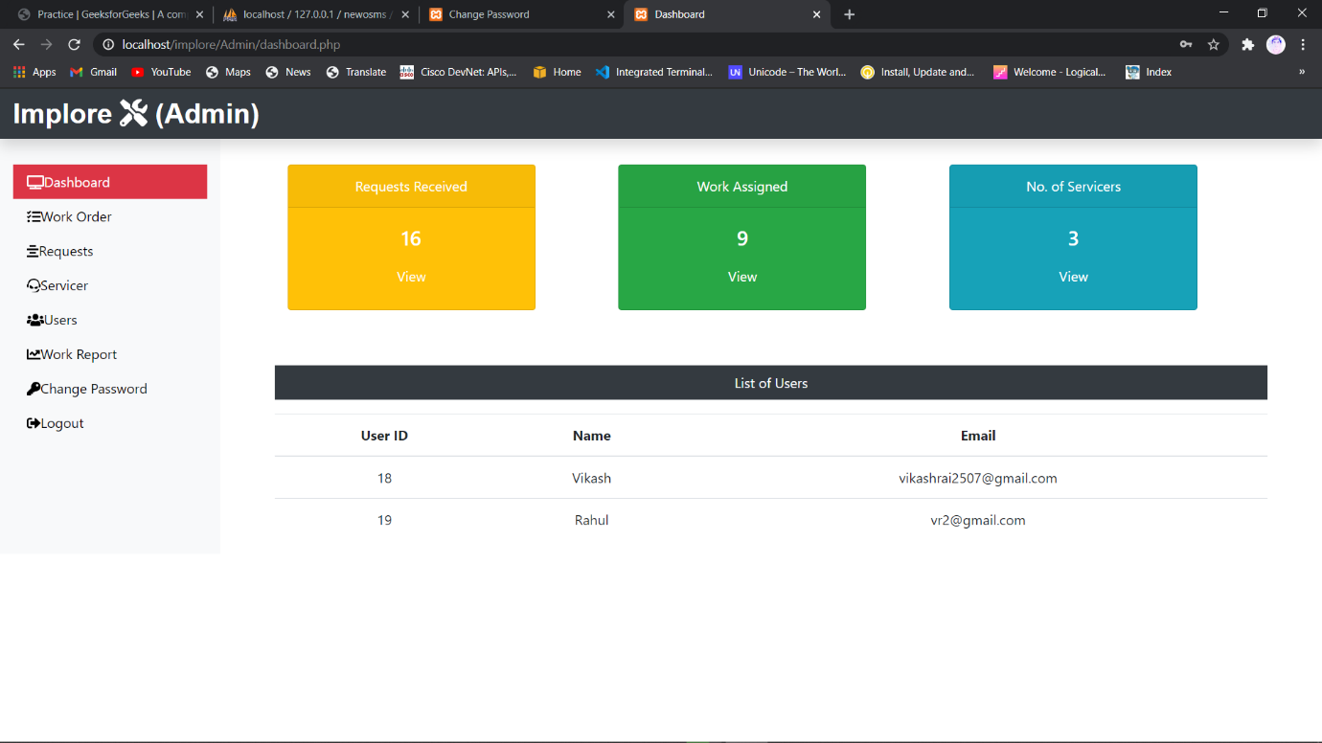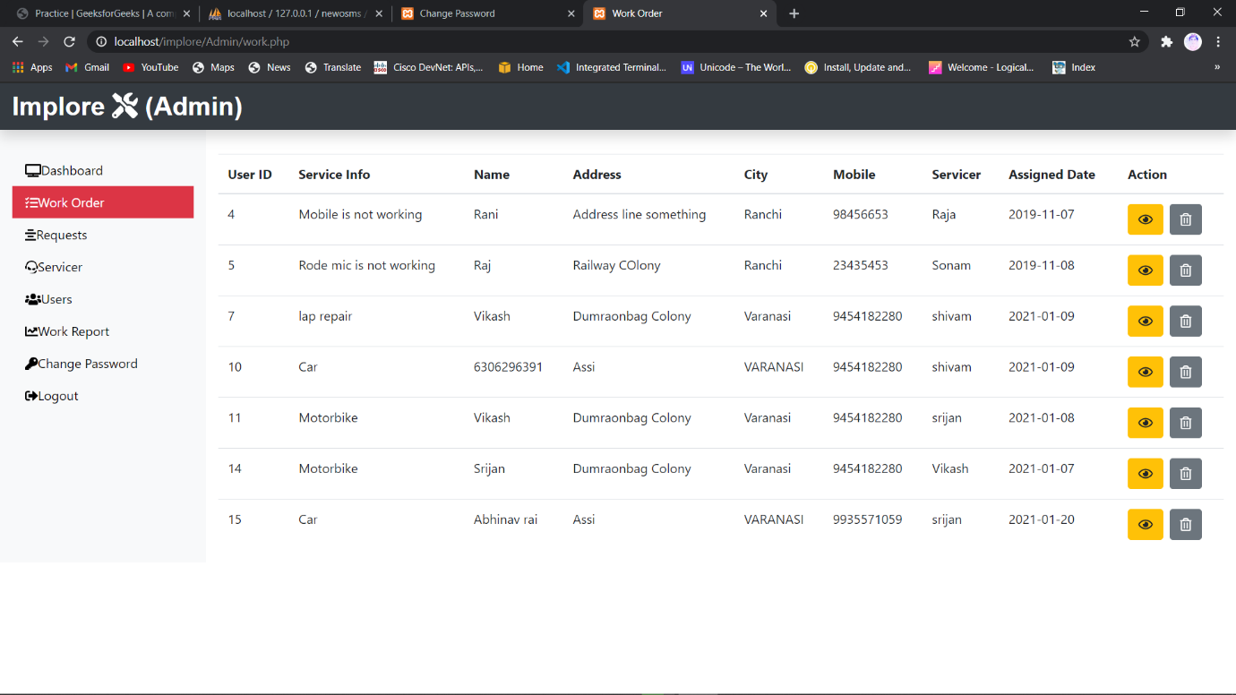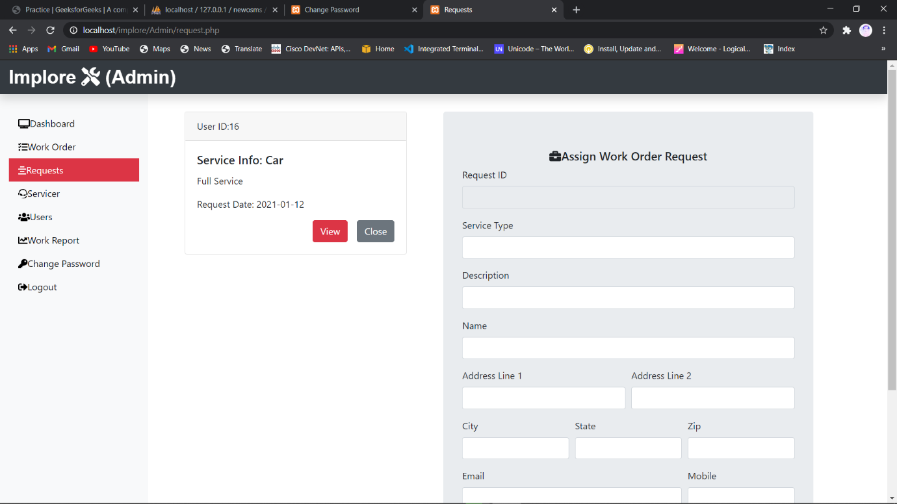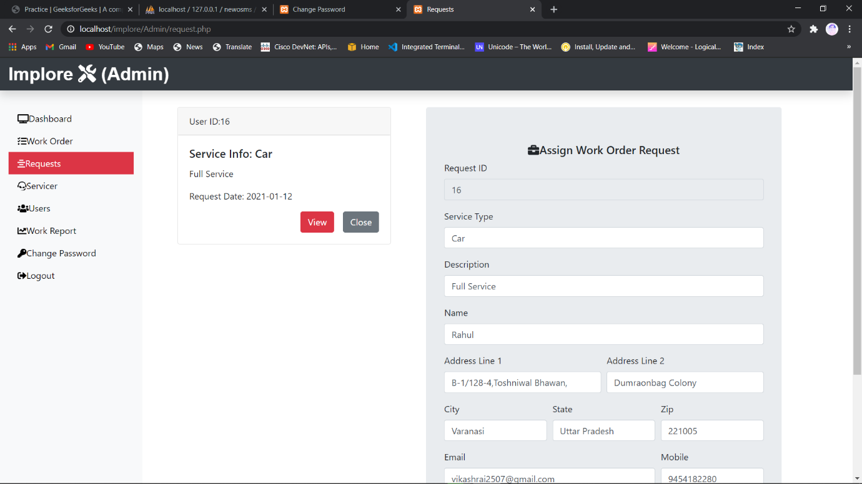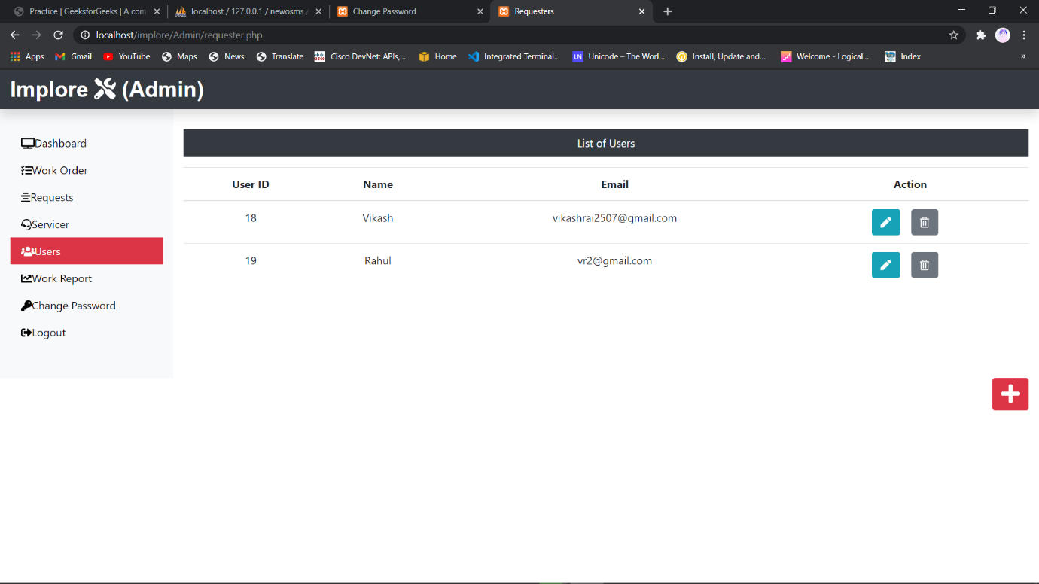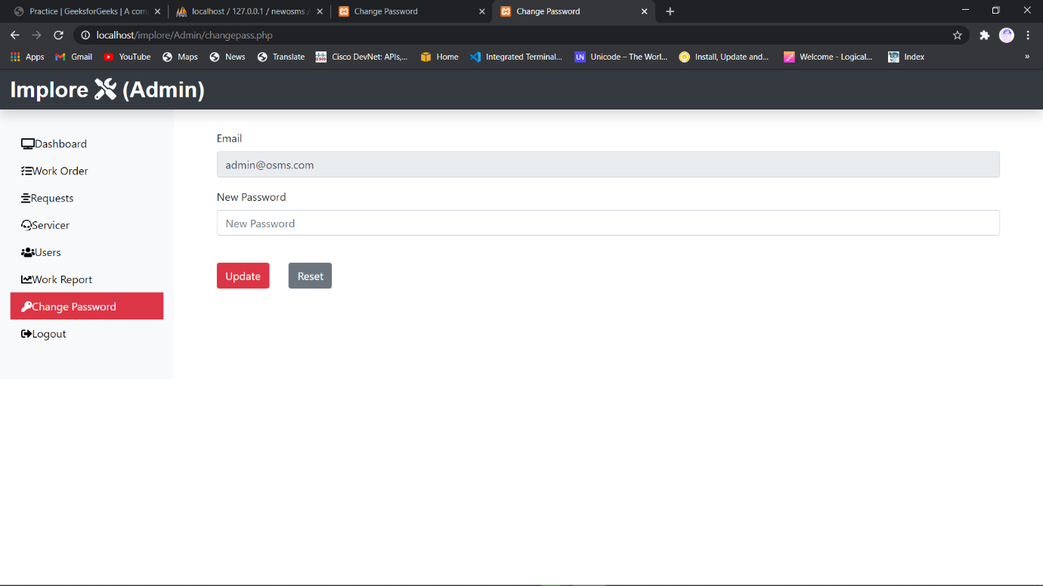

Login.php

<?php

**include**('../dbConnection.php');

**session_start**();

 if(!**isset**($_SESSION['is_adminlogin'])){

  if(**isset**($_REQUEST['aEmail'])){

   $aEmail = **mysqli_real_escape_string**($conn, **trim**($_REQUEST['aEmail']));

   $aPassword = **mysqli_real_escape_string**($conn, **trim**($_REQUEST['aPassword']));

   $sql = "SELECT a_email, a_password FROM adminlogin_tb WHERE a_email = '".$aEmail."' AND a_password = '".$aPassword."' limit 1";

   $result = $conn->**query**($sql);

   if($result->num_rows == 1){

    $_SESSION['is_adminlogin'] = true;

    $_SESSION['aEmail'] = $aEmail;

**echo** "<script> location.href='dashboard.php';</script>";

    exit;

   } else {

    $msg = '<div class="alert alert-warning mt-2">Enter Valid Email and Password</div>';

   }

  }

 } else {

**echo** "<script> location.href='dashboard.php';</script>";

 }

?>

<!DOCTYPE *html*>

<html *lang*="en">

<head>

 <meta *charset*="UTF-8">

 <meta *name*="viewport" *content*="width=device-width, initial-scale=1.0">

 <meta *http-equiv*="X-UA-Compatible" *content*="ie=edge">

*<!-- Bootstrap CSS -->*

 <link *rel*="stylesheet" *href*="../css/bootstrap.min.css">

*<!-- Font Awesome CSS -->*

 <link *rel*="stylesheet" *href*="../css/all.min.css">

 <style>

  .custom-margin {

   margin-top: 8vh;

  }

 </style>

 <title>Login</title>

</head>

<body>

 <div *class*="mb-3 mt-5 text-center bg-dark text-light" *style*="font-size: 30px;">

  <span>Implore <i *class*="fas fa-tools"></i></span>

 </div>

 <p *class*="text-center mt-10" *style*="font-size:35px;"><i *class*="fas fa-user-shield"></i>   Admin</p>

 <div *class*="container-fluid">

  <div *class*="row justify-content-center custom-margin">

   <div *class*="col-sm-6 col-md-4">

    <form *action*="" *class*="shadow-lg p-4" *method*="POST">

     <div *class*="form-group">

      <i *class*="fas fa-user"></i><label *for*="email" *class*="font-weight-bold pl-2">Email</label><input *type*="email" *class*="form-control" *placeholder*="Email" *name*="aEmail">

      <small *class*="form-text">We'll never share your email with anyone else.</small>

     </div>

     <div *class*="form-group">

      <i *class*="fas fa-key"></i><label *for*="pass" *class*="font-weight-bold pl-2">Password</label><input *type*="password" *class*="form-control" *placeholder*="Password" *name*="aPassword">

     </div>

     <button *type*="submit" *class*="btn btn-outline-primary mt-3 font-weight-bold btn-block shadow-sm">Login</button>

     <?php if(**isset**($msg)) {**echo** $msg;} ?>

    </form>

    <div *class*="text-center"><a *href*="../index.php" *class*="btn btn-success mt-3 font-weight-bold shadow-sm">Back to Home</a></div>

   </div>

  </div>

 </div>

*<!-- JavaScript Files -->*

 <script *src*="../js/jquery.min.js"></script>

 <script *src*="../js/popper.min.js"></script>

 <script *src*="../js/bootstrap.min.js"></script>

 <script *src*="../js/all.min.js"></script>

</body>

</html>

Dashboard.php

<?php

**define**('TITLE', 'Dashboard');

**define**('PAGE', 'dashboard');

**include**('includes/header.php');

**include**('../dbConnection.php');

**session_start**();

if(**isset**($_SESSION['is_adminlogin'])){

   $aEmail = $_SESSION['aEmail'];

} else {

**echo** "<script> location.href='login.php'</script>";

}

$sql = "SELECT **max**(request_id) FROM submitrequest_tb";

$result = $conn->**query**($sql);

$row = $result->**fetch_row**();

$submitrequest = $row[0];

$sql = "SELECT **max**(rno) FROM assignwork_tb";

$result = $conn->**query**($sql);

$row = $result->**fetch_row**();

$assignwork = $row[0];

$sql = "SELECT * FROM technician_tb";

$result = $conn->**query**($sql);

$totaltech = $result->num_rows;

?>

   <div *class*="col-sm-9 col-md-10"> *<!-- Start Dashboard 2nd Column -->*

    <div *class*="row text-center mx-5">

     <div *class*="col-sm-4 mt-5">

      <div *class*="card text-white bg-warning mb-3" *style*="max-width:18rem;">

       <div *class*="card-header">Requests Received</div>

       <div *class*="card-body">

        <h4 *class*="card-title"><?php **echo** $submitrequest; ?></h4>

        <a *class*="btn text-white" *href*="request.php">View</a>

       </div>

      </div>

     </div>

     <div *class*="col-sm-4 mt-5">

      <div *class*="card text-white bg-success mb-3" *style*="max-width:18rem;">

       <div *class*="card-header"> Work Assigned</div>

       <div *class*="card-body">

        <h4 *class*="card-title"><?php **echo** $assignwork; ?></h4>

        <a *class*="btn text-white" *href*="work.php">View</a>

       </div>

      </div>

     </div>

     <div *class*="col-sm-4 mt-5">

      <div *class*="card text-white bg-info mb-3" *style*="max-width:18rem;">

       <div *class*="card-header">No. of Servicers</div>

       <div *class*="card-body">

        <h4 *class*="card-title"><?php **echo** $totaltech; ?></h4>

        <a *class*="btn text-white" *href*="technician.php">View</a>

       </div>

      </div>

     </div>

    </div>

    <div *class*="mx-5 mt-5 text-center">

     <p *class*="bg-dark text-white p-2">List of Users</p>

     <?php

      $sql = "SELECT * FROM requesterlogin_tb";

      $result = $conn->**query**($sql);

      if($result->num_rows > 0){

**echo** '

       <table class="table">

        <thead>

         <tr>

          <th scope="col">User ID</th>

          <th scope="col">Name</th>

          <th scope="col">Email</th>

         </tr>

        </thead>

        <tbody>';

         while($row = $result->**fetch_assoc**()){

**echo** '<tr>';

**echo** '<td>'.$row["r_login_id"].'</td>';

**echo** '<td>'.$row["r_name"].'</td>';

**echo** '<td>'.$row["r_email"].'</td>';

**echo** '</tr>';

         }

**echo** '</tbody>

       </table>';

      } else {

**echo** '0 Result';

      }

     ?>

    </div>

   </div> *<!-- End Dashboard 2nd Column -->*

<?php **include**('includes/footer.php')?>

request.php

<?php

**define**('TITLE', 'Requests');

**define**('PAGE', 'request');

**include**('includes/header.php');

**include**('../dbConnection.php');

**session_start**();

if(**isset**($_SESSION['is_adminlogin'])){

   $aEmail = $_SESSION['aEmail'];

} else {

**echo** "<script> location.href='login.php'</script>";

}

?>

*<!-- Start 2nd Column -->*

<div *class*="col-sm-4 mb-5">

 <?php

  $sql = "SELECT request_id, request_info, request_desc, request_date FROM submitrequest_tb";

  $result = $conn->**query**($sql);

  if($result->num_rows > 0){

   while($row = $result->**fetch_assoc**()){

**echo** '<div class="card mt-5 mx-5">';

**echo** '<div class="card-header">';

**echo** 'User ID:'. $row['request_id'];

**echo** '</div>';

**echo** '<div class="card-body">';

**echo** '<h5 class="card-title">Service Info: '.$row['request_info'];

**echo** '</h5>';

**echo** '<p class="card-text">'.$row['request_desc'];

**echo** '</p>';

**echo** '<p class="card-text">Request Date: '.$row['request_date'];

**echo** '</p>';

**echo** '<div class="float-right">';

**echo** '<form action="" method="POST">';

**echo** '<input type="hidden" name="id" value='.$row["request_id"].'>';

**echo** '<input type="submit" class="btn btn-danger mr-3" value="View" name="view">';

**echo** '<input type="submit" class="btn btn-secondary" value="Close" name="close">';

**echo** '</form>';

**echo** '</div>';

**echo** '</div>';

**echo** '</div>';

   }

  }

 ?>

</div> *<!-- End 2nd Column -->*

<?php

**include**('assignworkform.php');

**include**('includes/footer.php');

?>

viewassignwork.php

<?php

**define**('TITLE', 'Work Order');

**define**('PAGE', 'work');

**include**('includes/header.php');

**include**('../dbConnection.php');

**session_start**();

if(**isset**($_SESSION['is_adminlogin'])){

   $aEmail = $_SESSION['aEmail'];

} else {

**echo** "<script> location.href='login.php'</script>";

}

?>

*<!-- Start 2nd COlumn -->*

<div *class*="col-sm-6 mt-5 mx-3">

 <h3 *class*="text-center">Assigned Work Details</h3>

 <?php

  if(**isset**($_REQUEST['view'])){

   $sql = "SELECT * FROM assignwork_tb WHERE request_id = {$_REQUEST['id']}";

   $result = $conn->**query**($sql);

   $row = $result->**fetch_assoc**(); ?>

   <table *class*="table table-bordered">

     <tbody>

      <tr>

       <td>Request ID</td>

       <td><?php if(**isset**($row['request_id'])){**echo** $row['request_id'];} ?></td>

      </tr>

      <tr>

       <td>Service Type</td>

       <td><?php if(**isset**($row['request_info'])){**echo** $row['request_info'];} ?></td>

      </tr>

      <tr>

       <td>Description</td>

       <td><?php if(**isset**($row['request_desc'])){**echo** $row['request_desc'];} ?></td>

      </tr>

      <tr>

       <td>Name</td>

       <td>

         <?php if(**isset**($row['requester_name'])) {**echo** $row['requester_name']; } ?>

       </td>

      </tr>

      <tr>

       <td>Address Line 1</td>

       <td>

         <?php if(**isset**($row['requester_add1'])) {**echo** $row['requester_add1']; } ?>

       </td>

      </tr>

      <tr>

       <td>Address Line 2</td>

       <td>

         <?php if(**isset**($row['requester_add2'])) {**echo** $row['requester_add2']; } ?>

       </td>

      </tr>

      <tr>

       <td>City</td>

       <td>

         <?php if(**isset**($row['requester_city'])) {**echo** $row['requester_city']; } ?>

       </td>

      </tr>

      <tr>

       <td>State</td>

       <td>

         <?php if(**isset**($row['requester_state'])) {**echo** $row['requester_state']; } ?>

       </td>

      </tr>

      <tr>

       <td>Pin Code</td>

       <td>

         <?php if(**isset**($row['requester_zip'])) {**echo** $row['requester_zip']; } ?>

       </td>

      </tr>

      <tr>

       <td>Email</td>

       <td>

         <?php if(**isset**($row['requester_email'])) {**echo** $row['requester_email']; } ?>

       </td>

      </tr>

      <tr>

       <td>Mobile</td>

       <td>

         <?php if(**isset**($row['requester_mobile'])) {**echo** $row['requester_mobile']; } ?>

       </td>

      </tr>

      <tr>

       <td>Service Date</td>

       <td>

         <?php if(**isset**($row['assign_date'])) {**echo** $row['assign_date']; } ?>

       </td>

      </tr>

      <tr>

       <td>Servicer Name</td>

       <td><?php if(**isset**($row['assign_tech'])) {**echo** $row['assign_tech']; } ?></td>

      </tr>

      <tr>

       <td>Customer Sign</td>

       <td></td>

      </tr>

      <tr>

       <td>Servicer Sign</td>

       <td></td>

      </tr>

     </tbody>

    </table>

    <div *class*="text-center">

     <form *action*="" *class*="mb-3 d-print-none d-inline">

      <input *class*="btn btn-danger" *type*="submit" *value*="Print" *onClick*="window.print()"> </form>

      <form *action*="work.php" *class*="mb-3 d-print-none d-inline"><input *class*="btn btn-secondary" *type*="submit" *value*="Close">

     </form>

    </div>

 <?php }?>

</div>

*<!-- End 2nd COlumn -->*

<?php **include**('includes/footer.php')?>

Technician.php

<?php

**define**('TITLE', 'Technician');

**define**('PAGE', 'technician');

**include**('includes/header.php');

**include**('../dbConnection.php');

**session_start**();

if(**isset**($_SESSION['is_adminlogin'])){

   $aEmail = $_SESSION['aEmail'];

} else {

**echo** "<script> location.href='login.php'</script>";

}

?>

*<!-- Start 2nd Column -->*

<div *class*="col-sm-9 col-md-10 mt-5 text-center">

 <p *class*="bg-dark text-white p-2">List of Servicers</p>

 <?php

  $sql = "SELECT * FROM technician_tb";

  $result = $conn->**query**($sql);

  if($result->num_rows > 0){

**echo** '<table class="table">';

**echo** '<thead>';

**echo** '<tr>';

**echo** '<th scope="col">Servicer ID</th>';

**echo** '<th scope="col">Name</th>';

**echo** '<th scope="col">City</th>';

**echo** '<th scope="col">Mobile</th>';

**echo** '<th scope="col">Email</th>';

**echo** '<th scope="col">Action</th>';

**echo** '</tr>';

**echo** '</thead>';

**echo** '<tbody>';

     while($row = $result->**fetch_assoc**()){

**echo** '<tr>';

**echo** '<td>'.$row["empid"].'</td>';

**echo** '<td>'.$row["empName"].'</td>';

**echo** '<td>'.$row["empCity"].'</td>';

**echo** '<td>'.$row["empMobile"].'</td>';

**echo** '<td>'.$row["empEmail"].'</td>';

**echo** '<td>';

**echo** '<form action="editemp.php" class="d-inline" method="POST">';

**echo** '<input type="hidden" name="id" value='.$row["empid"].'><button type="submit" class="btn btn-info mr-3" name="edit" value="Edit"><i class="fas fa-pen"></i></button>';

**echo** '</form>';

**echo** '<form action="" method="POST" class="d-inline">';

**echo** '<input type="hidden" name="id" value='.$row["empid"].'><button type="submit" class="btn btn-secondary mr-3" name="delete" value="Delete"><i class="far fa-trash-alt"></i></button>';

**echo** '</form>';

**echo** '</td>';

**echo** '</tr>';

     }

**echo** '</tbody>';

**echo** '</table>';

  } else {

**echo** '0 Result';

  }

 ?>

</div>

<?php

 if(**isset**($_REQUEST['delete'])){

 $sql = "DELETE FROM technician_tb WHERE empid = {$_REQUEST['id']}";

 if($conn->**query**($sql) == TRUE){

**echo** '<meta http-equiv="refresh" content= "0;URL=?deleted" />';

 } else {

**echo** 'Unable to Delete';

 }

 }

?>

  </div> *<!-- End Row -->*

  <div *class*="float-right"><a *href*="insertemp.php" *class*="btn btn-danger"><i *class*="fas fa-plus fa-2x"></i></a></div>

 </div> *<!-- End Container -->*

*<!-- JavaScript -->*

  <script *src*="../js/jquery.min.js"></script>

  <script *src*="../js/popper.min.js"></script>

  <script *src*="../js/bootstrap.min.js"></script>

  <script *src*="../js/all.min.js"></script>

 </body>

</html>

Changepass.php

<?php

**define**('TITLE', 'Change Password');

**define**('PAGE', 'changepass');

**include**('includes/header.php');

**include**('../dbConnection.php');

**session_start**();

 if(**isset**($_SESSION['is_adminlogin'])){

  $aEmail = $_SESSION['aEmail'];

 } else {

**echo** "<script> location.href='login.php'; </script>";

 }

 $aEmail = $_SESSION['aEmail'];

if(**isset**($_REQUEST['passupdate'])){

 if($_REQUEST['aPassword'] == ""){

  $passmsg = '<div class="alert alert-warning col-sm-6 ml-5 mt-2">Fill All Fields</div>';

 } else {

  $aPass = $_REQUEST['aPassword'];

  $sql = "UPDATE adminlogin_tb SET a_password = '$aPass' WHERE a_email = '$aEmail'";

  if($conn->**query**($sql) == TRUE){

   $passmsg = '<div class="alert alert-success col-sm-6 ml-5 mt-2">Updated Successfully</div>';

  } else {

   $passmsg = '<div class="alert alert-danger col-sm-6 ml-5 mt-2">Unable to Update</div>';

  }

 }

}

?>

<div *class*="col-sm-9 col-md-10"> *<!-- Start Admin Change Password Form 2nd Column -->*

 <form *class*="mt-5 mx-5" *action*="" *method*="POST">

  <div *class*="form-group">

   <label *for*="inputEmail">Email</label>

   <input *type*="email" *class*="form-control" *id*="inputEmail" *value*="<?php **echo** $aEmail; ?>" *readonly*>

  </div>

  <div *class*="form-group">

   <label *for*="inputnewpassword">New Password</label>

   <input *type*="password" *class*="form-control" *id*="inputnewpassword" *placeholder*="New Password" *name*="aPassword">

  </div>

  <button *type*="submit" *class*="btn btn-danger mr-4 mt-4" *name*="passupdate">Update</button>

  <button *type*="reset" *class*="btn btn-secondary mt-4">Reset</button>

  <?php if(**isset**($passmsg)){**echo** $passmsg;} ?>

 </form>

</div> *<!-- End Admin Change Password Form 2nd Column -->*

<?php **include**('includes/footer.php')?>

editreq.php

<?php

**define**('TITLE', 'Update Requester');

**define**('PAGE', 'requesters');

**include**('includes/header.php');

**include**('../dbConnection.php');

**session_start**();

 if(**isset**($_SESSION['is_adminlogin'])){

  $aEmail = $_SESSION['aEmail'];

 } else {

**echo** "<script> location.href='login.php'; </script>";

 }

 ?>

*<!-- Start 2nd COlumn -->*

 <div *class*="col-sm-6 mt-5 mx-3 jumbotron">

  <h3 *class*="text-center">Update Requester Details</h3>

  <?php

   if(**isset**($_REQUEST['edit'])){

   $sql = "SELECT * FROM requesterlogin_tb WHERE r_login_id = {$_REQUEST['id']}";

   $result = $conn->**query**($sql);

   $row = $result->**fetch_assoc**();

   }

   if(**isset**($_REQUEST['requpdate'])){

    if(($_REQUEST['r_login_id'] == "") || ($_REQUEST['r_name'] == "") || ($_REQUEST['r_email'] == "")){

     $msg = '<div class="alert alert-warning col-sm-6 ml-5 mt-2" role="alert">Fill All Fileds</div>';

    } else {

     $rid = $_REQUEST['r_login_id'];

     $rname = $_REQUEST['r_name'];

     $remail = $_REQUEST['r_email'];

     $sql = "UPDATE requesterlogin_tb SET r_login_id = '$rid', r_name = '$rname', r_email = '$remail' WHERE r_login_id = '$rid'";

     if($conn->**query**($sql) ==  TRUE){

      $msg = '<div class="alert alert-success col-sm-6 ml-5 mt-2" role="alert">Updated Successfully</div>';

     } else {

      $msg = '<div class="alert alert-danger col-sm-6 ml-5 mt-2" role="alert">Unable to Update</div>';

     }

    }

   }

  ?>

  <form *action*="" *method*="POST">

   <div *class*="form-group">

    <label *for*="r_login_id">Requester ID</label>

    <input *type*="text" *class*="form-control" *name*="r_login_id" *id*="r_login_id" *Value*="<?php if(**isset**($row['r_login_id'])) { **echo** $row['r_login_id']; } ?>" *readonly*>

   </div>

   <div *class*="form-group">

    <label *for*="r_name">Name</label>

    <input *type*="text" *class*="form-control" *name*="r_name" *id*="r_name" *Value*="<?php if(**isset**($row['r_name'])) { **echo** $row['r_name']; } ?>">

   </div>

   <div *class*="form-group">

    <label *for*="r_email">Email</label>

    <input *type*="text" *class*="form-control" *name*="r_email" *id*="r_email" *Value*="<?php if(**isset**($row['r_email'])) { **echo** $row['r_email']; } ?>">

   </div>

   <div *class*="text-center">

    <button *type*="submit" *class*="btn btn-danger" *id*="requpdate" *name*="requpdate">Update</button>

    <a *href*="requester.php" *class*="btn btn-secondary">Close</a>

   </div>

   <?php if(**isset**($msg)) {**echo** $msg; } ?>

  </form>

 </div> *<!-- End 2nd COlumn -->*

<?php

**include**('includes/footer.php');

?>

Implementation

Our dedication to our Clients goes well beyond the deployment of our software. We are committed to providing our Client with a positive experience that starts with a successful implementation.

Implementation is the stage in the project where the theoretical design is turned into a working system. The implementation phase constructs, installs and operates the new system. The most stage is achieving a new successful system is that it will work efficiently and effectively.

Security and integrity of database are very important for any software system because databases are the backbone of the system. Security need to be implanted at every level of the system so that only authorized user can access the system for updation and other significance process.

Limitations

* SMS alert facility is not available.
* Portal is not SEO friendly
* Registration Email Verification Not available
* Risk unauthorized accessibility
* Future Scope

The various things can be made it simple and user friendly. As by increasing some of the coding we can improve it functionality. Online payment system is yet not integrated to the system which can be featured in the near future.

Till now it does not have the facility of back up the database. By as the next advancement we can make it able to bundle the backup facility so that one can perform operation based on previous records.

As the technology emerges, it is possible to upgrade the system and can be adaptable to desired environment.

Based on the future security issued, security can be improved using emerging technologies.

Conclusion

The Implore (Vehicle Service Provider Website ) has been computed successfully and was also tested successfully by taking "Test Cases". It is user friendly, and has required options, which can be utilized by the user to perform the desired operations.

The Software is developed using HTML, CSS, JS as front end and PHP, MySql as back end in windows environment.

The goals that are achieved by the software are:

* Simplification of the operations
* Less processing time and getting required information
* User friendly
* Portable and flexible for further enhancement

Bibliography

The following reference has been used to develop the project “Implore” :-

**Books: -**

* The Complete Reference PHP
* Head First SQL: Your Brain on SQL by Lynn Beighley

**Web Source: -**

* www.google.co.in
* www.wikipedia.org
* www.tutorialspoint.com
* www.stackoverflow.com
* www.docs.microsoft.com